1. 
2. Decomposition Pattern:
   1. Decomposition By Business Domain
   2. Decomposition by Sub-Domain
3. Before Decomposition, let’s see the kinds of projects coming under microservices.
4. 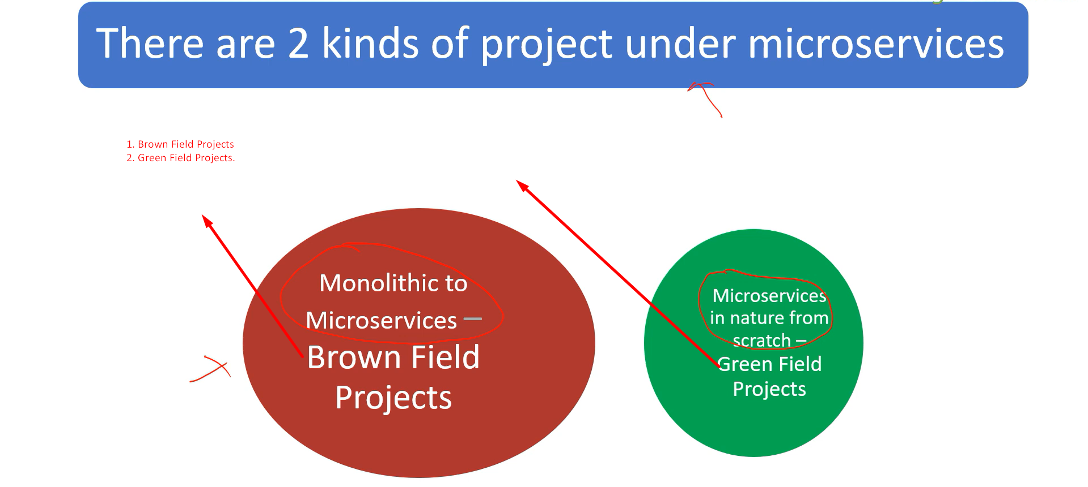
5. 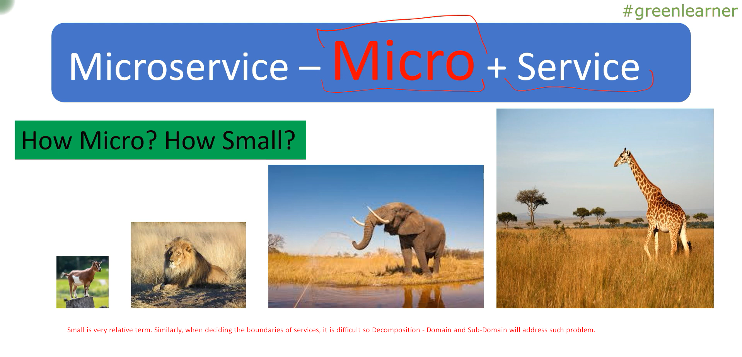
6. <https://youtu.be/_U36FMfU1-M?list=PLq3uEqRnr_2EDsuxPboP9_WtVRR_TaMrF&t=141>